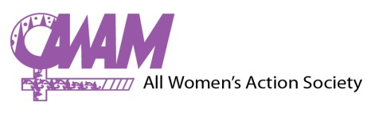

The All Women’s Action Society (AWAM) is an independent, non-profit women’s organisation working to create a just, democratic and equitable society.

Our work involves lobbying for legal reform, training and campaigns to raise awareness on women’s rights, as well as providing counselling and legal information for women facing violence and discrimination.

AWAM would like to invite applications for the following vacancy:

Title: Assistant Programme Officer
Start date: mid February 2015 or as negotiated with AWAM. The position will be on contract basis for an initial one-year period with yearly renewals.
Salary: Salary will commensurate with experience.

Key Responsibilities:

- Liaison Staff (Joint AWAM collaboration)
- Communications and coordination: Coordinate communications with a key partner organisation about AWAM’s work and women’s human rights situation in Malaysia. This includes coordination of joint training activities, and reporting on these activities.

- Gender-Based Violence work
- GBV Committee: Assist in the coordination of the Gender Based Violence (GBV) Committee, including arrange for meetings and documenting meetings,
- GBV campaigns and events: Assist in the coordination and implementation of GBV campaigns and activities according to plans and budget, including event management, mobilising participation, making logistical arrangements, coordinating evaluations of workshops and following up with participants.

- Public Education and Training work
- Public Education and Trainings: Assist in coordinating AWAM public education and training activities, including responses to external requests for trainings, contacting resource persons, and making logistical arrangements,
- Assist in the coordination of any other campaigns/events as necessary.

Requirements:
• Understanding of and commitment to human rights and gender equality.
• Preferred: Experience in coordinating, organising and training.
• A degree or experience related to women’s rights would be advantageous.
• Good spoken and written English and Malay language skills.
• Team player with a positive attitude, and as well as able to work independently.

How to apply:
Applications should contain:
(1) a resume,
(2) a cover letter addressing the above requirements, and
(3) contact details of 2 referees.

Please send applications to Emily O. Mathius at finance.awam@gmail.com, with the subject heading: Application for Assistant Programme Officer Position. Closing date is 31 January 2015.

AWAM thanks all applicants for their interest. Only shortlisted applicants will be contacted.

