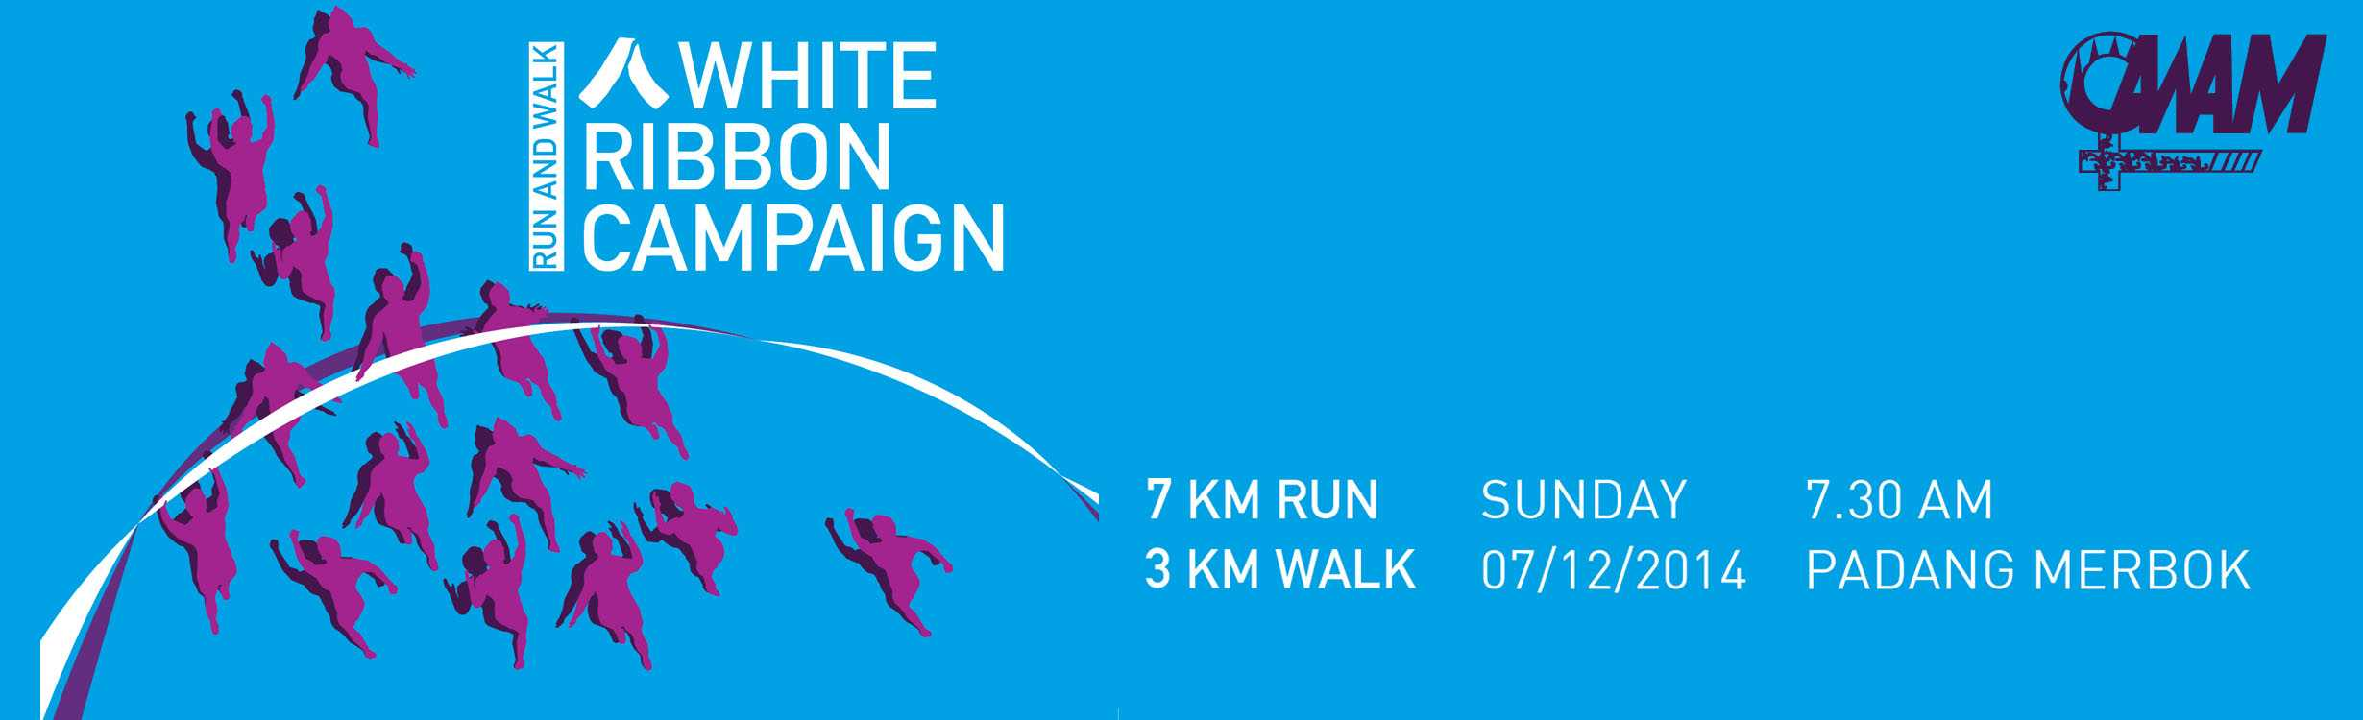
 | TERMS & CONDITIONS
 | - The All Women’s Action Society (AWAM) White Ribbon Run and Walk is open to all Malaysians and expatriates.  - The 7km run is open to participants 12 years old and above as of 7th December 2014.  - The 3km walk is open to families with children. Registration fee is applicable to all family members who are 12 years old and above. Men are encouraged to be seen walking with their children in strollers.  - Those below 18 years old need to obtain parental consent to participate.  - Registration fees is RM45/= per participant 12 years and above. Registration is available online via www.myraceonline.com OR walk-in for offline registration at AWAM office in PJ from 10am – 4pm (Monday to Saturday).  - All participants will be notified to collect the race kit before 6th December 2014 and goodies upon returning from the run or walk on event day. |  |  | - Lucky draw is open to all participants who have completed the run or walk. All lucky draw winners must produce their number bib to claim for lucky draw prizes.  - There will be NO refund if the event is cancelled for reason of force majeure i.e. due to occurrence of incidents that are beyond the control of the organizer and which renders it impossible or unsafe to hold the event.  - Closing date: 7th November 2014 at 5pm. We still welcome offline registrations after the closing date but are unable to guarantee your t-shirt size.  - All cheques are to be crossed and made payable to “All Women’s Action Society (AWAM)”.  11. Please bank in the entry fee directly to AWAM’s account at : 106-00-01265-6 at Hong Leong Bank then fax your entry form and bank-in-slip to AWAM; or submit your entry form personally at AWAM’s office (see below for address).  12. Confirmation of registration will be sent via e-mail to the participant.
 | REGISTRATION
I wish to participate in the Run, 7km White Ribbon / Walk, 3km White Ribbon* and agree to abide by the terms and conditions of the run stated above. I certify that all particulars given below are correct. I am entering the run/walk at my own risk and shall not hold the organizers or sponsors responsible for any accident/injury/death/loss or property occurring before, during or after the competitions. I grant full permission to the organizers to use my name and likeness, as well as photographers and video/audio recordings of me, and quotations from me in legitimate accounts and promotions of this event appearing in any print, electronic or digital medium.
Name: New IC/Ppt No.: Date of Birth :
Add: , (Postcode) (City) (State)
Email : H/P Nos: Alternate H/P No.:
Sex:  M  F T-Shirt Size (chest measurement) :  XS=36”  S=38”  M=40”  L=42”  XL=44”  XXL=46”
Emergency Contact Person : H/P Nos:

--------------------------------------
Note : * delete when necessary
Participant’s Signature

Parent / Guardian Consent Section
I, (NRIC : ) (signature : )being the parent/lawful guardian of the above participant hereby consent to my child participation in the White Ribbon Run. I have read, understood and agree to be bound by the terms and conditions of this event. I hereby agree that I will not hold the organizers, their agents and/or staff liable in whatsoever manner for any injury, death, loss and/or damages suffered by my child or any of them arising from or in connection with this event including but not limited to his/her/their participation or howsoever caused by the organizers, their agents and/or staff, as the case may be.
 | Please direct all enquiries and entry form to :  All Women’s Action Society (AWAM)  85, Jln 21/1, SEA Park, 46300 Petaling Jaya, Selangor.  Tel: 03-78774221 (Ms Choong Yong Yi) Fax: 03-78743312  E-mail: allwomensactionsociety@gmail.com  website: www.awam.org.my | FOR OFFICE USE ONLY  Receive by Date  Amount RM Cheque No.  Receipt No. Bib No. |  |  | ACKNOWLEDGEMENT  Cash / Cheque Amount  RM Cheque No.  Date .............. Pax ...........  Receipt No.

